**Features of the Project**

**Kiosk**

* Enter or search name
* Select Category

**Front-end –** ganito ang sa front-end

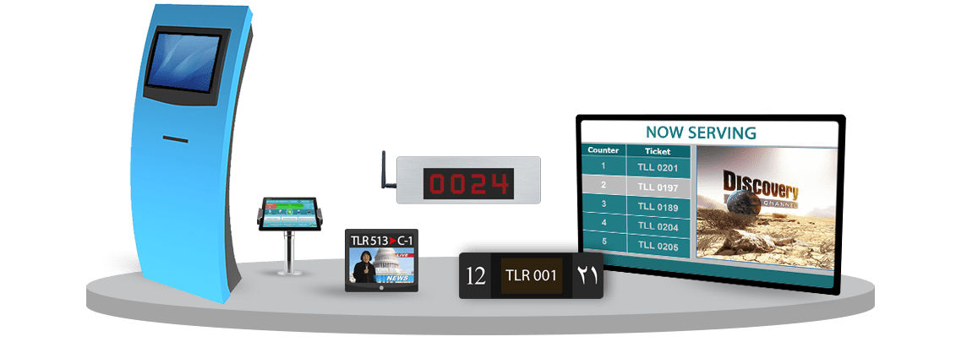

**Login Form**

**Admin Dashboard**

* Number of customers
* Number of served transactions today

**Customer Management**

* Full name
* Contact

**User Management**

* Full name
* Contact
* Address
* Username
* Password

**Counter #**

* Number

**Category**

* Category name

**Que List**

* Counter number
* Customer
* Category

**Ads Management**

* Video or Image Upload
* Status – Active, Inactive

**Que Report Archive**

* Category Name
* Counter number
* Customer
* Date/Time
* Status – completed, skipped

**Report by Counter**

**Report by Category**

